EXPT NO: 7 Clustering using K-Means and Gaussian Mixture Models (GMM)
DATE: 08.04.2026

SCENARIO 1 – CLUSTERING USING K-MEANS
Elbow curve (K vs inertia):
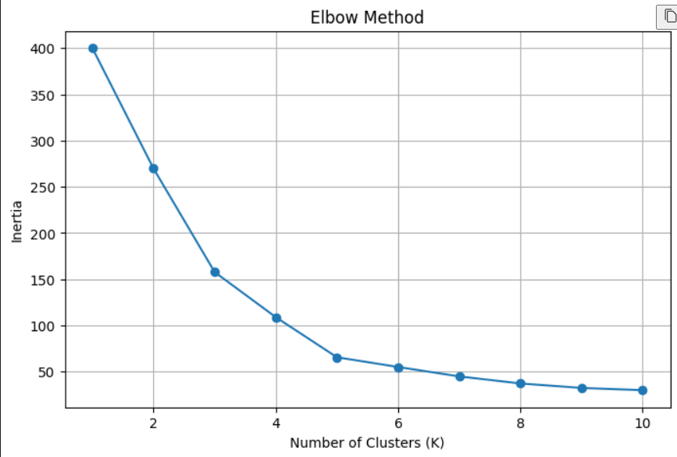
Cluster centroids:
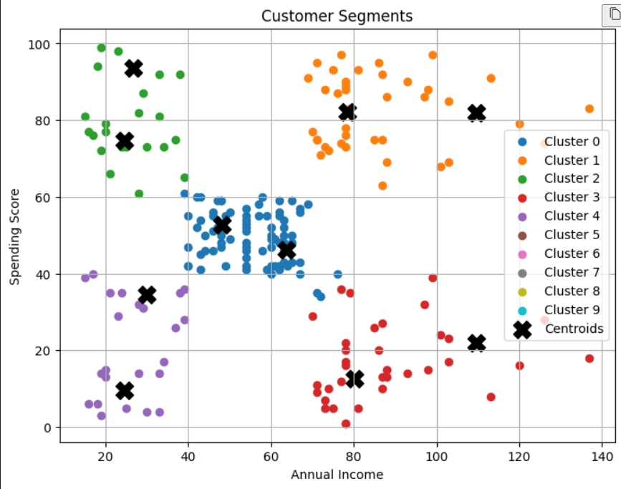

SCENARIO 2 – CLUSTERING USING GMM
AIC & BIC:
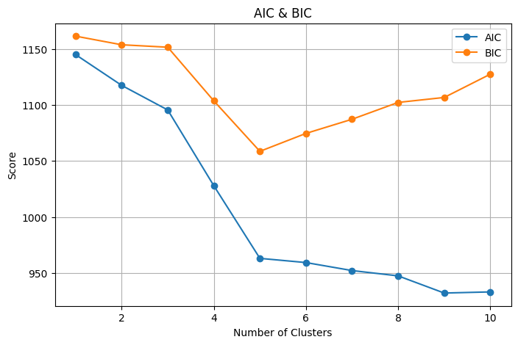

GMM CLUSTERING:
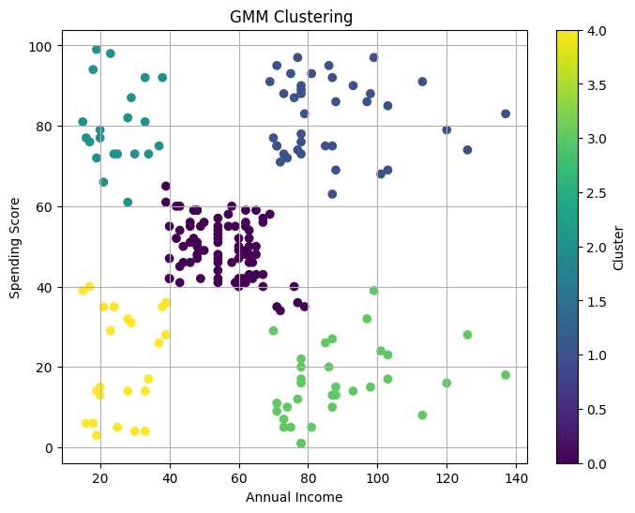

GMM WITH CLUSTER CENTERS:
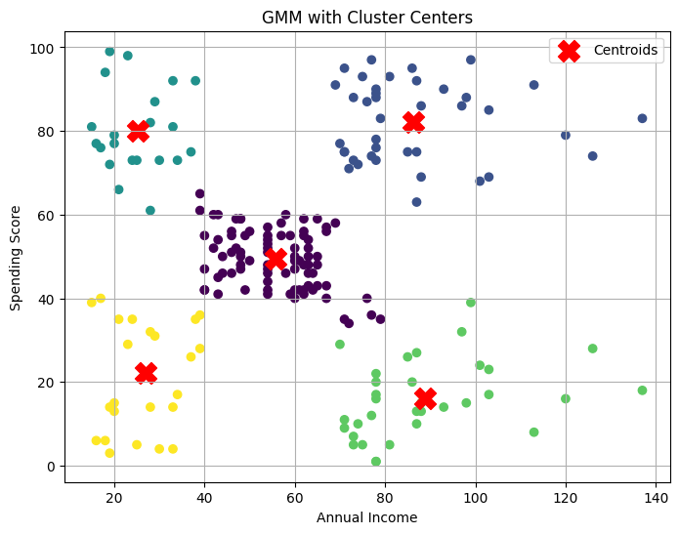
GMM CONTOUR PLOT:
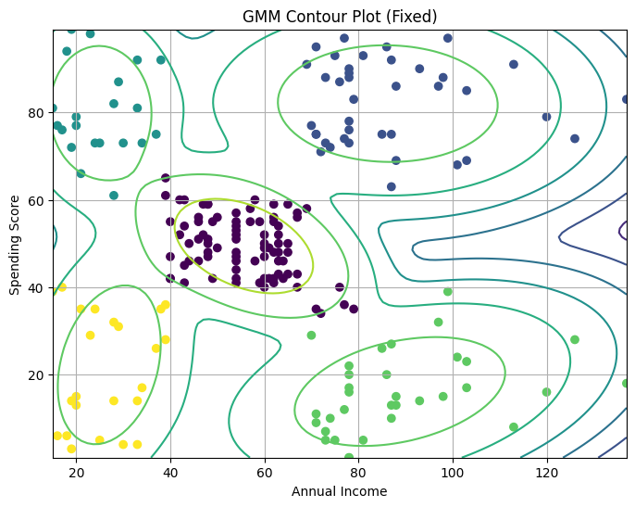

CLUSTER CONFIDENCE DISTRIBUTION:
